**Hole Radius based on frame fixing combo.**

Hole Position

|  |  |
| --- | --- |
| D/B-7.0 | 3.5 |
| D/B-3.5 | 1.8 |

**Number of holes based on total length**

1. **Type 1**

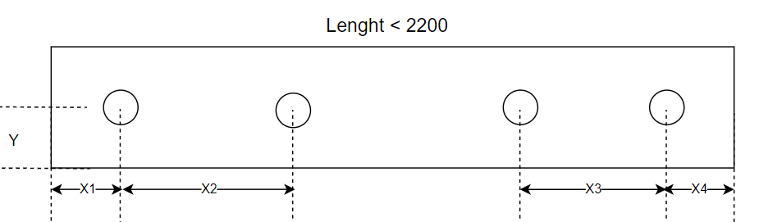

SDF: Hole Position

**Variable**

|  |  |  |
| --- | --- | --- |
| **No** | **Parameter** | **Value/Equation** |
| 3 | X1 | Architrave1 + StopHgt1 + 175 |
| 4 | X2 | 525 |
| 5 | X3 | 525 |
| 6 | X4 | 175 |
| 8 | Y | Return1 + Architrave1 + Rebate1 + (Throat/2) |

1. **Type 2**

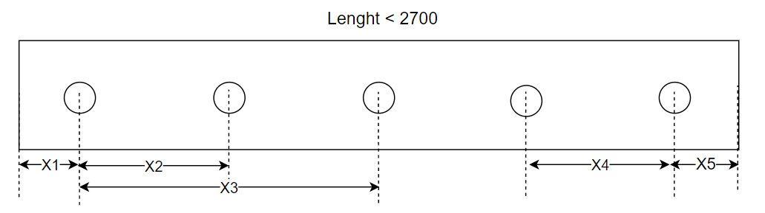

**Variable**

|  |  |  |
| --- | --- | --- |
| **No** | **Parameter** | **Value/Equation** |
| 1 | X1 | Architrave1 + StopHgt1 + 175 |
| 2 | X2 | 525 |
| 3 | X3 | (X5-X1)/2 |
| 4 | X4 | 525 |
| 5 | X5 | 175 |
| 6 | Y | Return1 + Architrave1 + Rebate1 + (Throat/2) |

1. **Type 3**

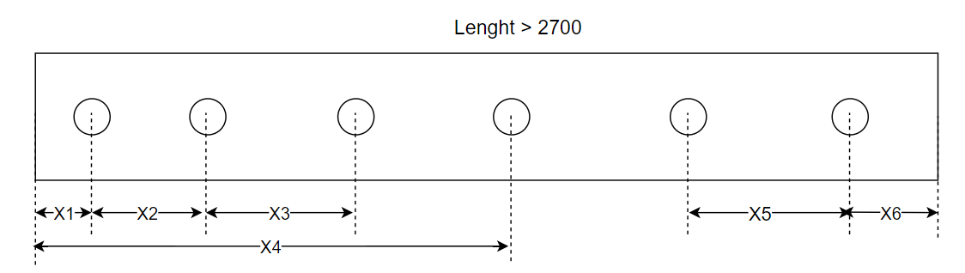

**Variable**

|  |  |  |
| --- | --- | --- |
| **No** | **Parameter** | **Value/Equation** |
| 1 | X1 | Architrave1 + StopHgt1 + 175 |
| 2 | X2 | 525 |
| 3 | X3 | 525 |
| 4 | X4 | (X1-X6)/2 |
| 5 | X5 | 525 |
| 6 | X6 | 175 |
| 7 | Y | Return1 + Architrave1 + Rebate1 + (Throat/2) |

|  |  |
| --- | --- |
| Class | Method |
| HingeTools | GetFrmFixedPoints() |
| DrawHoles() |